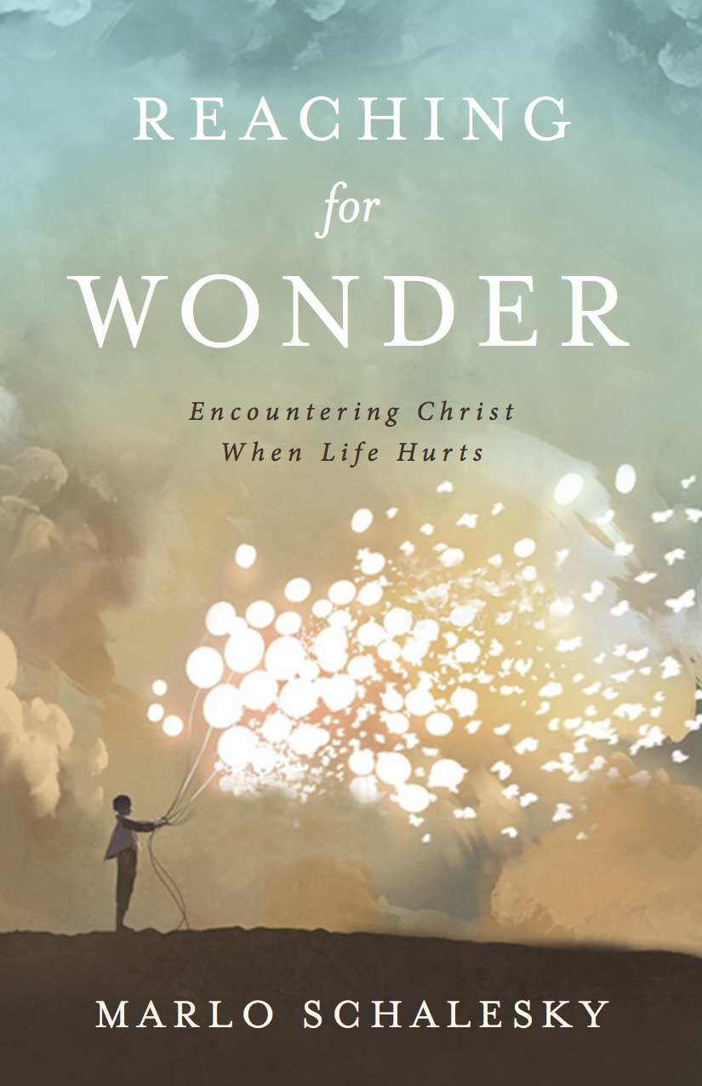
DISCUSSION QUESTIONS
For GROUPS

REACHING FOR WONDER
By Marlo Schalesky

www.VividGod.com
www.MarloSchalesky.com

Ideally, questions and discussion will arise naturally in your group as you dig deeper into each chapter and how it relates to your lives. Below are some suggested questions to help get your group started. However, the Holy Spirit may lead your group in another direction as you explore the concepts in Reaching for Wonder. Be sensitive to the Spirit and to the sensitive places in the life and experience of your group as you reach out to discover His wonder together, especially in those tender places where life hurts.

Introduction
We come to God in the difficulties of life and want our circumstances to be fixed. We want him to make it all better. But what if seeing God more clearly, more deeply, is the true goal of the spiritual life? What if He is more than we ever dreamed?

1) When you were a kid, what did you want your life to look like when you grew up? What were your plans and dreams?

2) How is your life like unlike your childhood dreams for it?

3) What key concern has arisen in your life that you had not anticipated? Talk about the difference between what you’re praying for and what you are currently experiencing in this area of your life.

CHAPTER 1: Reaching through Doubt – If You are Willing
Sometimes we know God has the ability to fix our circumstances, but we don’t know if he’s willing. Sometimes we’re afraid that even though he has the power, he will abandon us to go it alone. Sometimes what we really need is for God to hear our doubts, draw near, and simply say, “I am willing…”

1) Why do you think the leper begins his encounter with Jesus with the word, “if”? Is it a lack of faith, a lack of understanding, or a lack of confidence? What in the leper’s life would contribute to him using this “if” approach?

2) Talk about a time in your own life when you came to God with an “if.” What happened? How did God seem to respond? If you were to approach God again with the same issue, how might your prayers be different? How might your attitude be different?

3) If God were to speak to you about your current doubts, the “if” places you now have in your life, what do you think he’d say? What do you think he’d say to the person sitting next to you about their “ifs”?

CHAPTER 2: Reaching through Shame – You’ve Had Five Husbands
Shame. Guilt. Embarrassment. Fear. There are things in all of our lives that we hope no one will ever find out about, that will hope will be hidden forever. But the story of the woman at the well tells us something different. It tells us that Jesus can transform the very places of our deepest pain and shame and use them for his glory. Instead of being ashamed, we can be filled with wonder. For many of us, that would change everything.

1) Why do you think we want so desperately to hide our failings, even when others are already aware of them?

2) How would your life change if your hidden shame was transformed into something that glorified and drew others to God?

3) What would it take for you to leave your empty jar at the well and live in aletheia? What one step can you take today to allow God to reveal the ugly places in your life and transform them into wonder?

CHAPTER 3: Reaching through Helplessness–Lowered through a Roof
“God helps those who help themselves,” Benjamin Franklin once said. But sometimes, we can’t help ourselves. Sometimes there’s nothing we can do. Sometimes we are as helpless to help ourselves as a paralyzed man on a mat. And sometimes that helplessness is the hardest thing of all. But God reaches out to us when we cannot reach at all. When we can’t part the crowd, he provides stairs to the roof.

1) Why didn’t Jesus just part the crowd? Why do you think the friends had to climb up to the roof and dig a hole? What did that demonstrate about the friends, and about the paralyzed man?

2) Why do you think God sometimes chooses the hard way for us?

3) Have you had times in your when you’ve been helpless, but God provided help? How did that affect you and your faith? Were you able to be more fully healed because others were involved?

CHAPTER 4: Reaching through Loss – A Widow’s Dead Son
The pile-on effect can shake even the sturdiest faith. When loss is followed by loss and more loss, it’s hard to keep hoping, keep believing, not give up. But when our internal crowd of mourning meets Christ’s crowd at the gates of our lives, transformation takes place. What would it be like if God met you at the gate between safety and the unknown and changed your mourning to hope?

1) Have you ever experienced the “pile-on” effect? What happened and how did you feel?

2) Have you ever felt that all is lost and there is no hope for redemption in a situation? If so, how did you move toward the city gate? How did you move on to a place where you could meet Jesus? Or did you?

3) After reading this chapter, are there any places in your life that seem dead and beyond hope. Can you imagine bringing those “dead bodies” to the gate to meet Jesus? Can others walk with you to encounter Him? What would that look like for you?

CHAPTER 5: Reaching through the Voices Within – We are Legion
The story of the man with a legion of demons seems like a strange one. But none of us are immune to the destructive voices in our own heads. We all hear lies and deceptions, and sometimes we succumb to them. But Jesus can free us, even when nothing else has helped, so that the only voices we hear are his and our own. He gives us the clarity to hear the truth.

1) What are some of the destructive things that go through your mind?

2) How have you fought those voices in the past? And how do these voices usually make themselves known to you? When are you the most susceptible to believing lies?

3) If Jesus were standing here now, what do you think he’d say to you? (Suggested exercise: Have group members write letters to themselves from God, imagining what God might write to them. Share snippets of the letters together in the group, whatever group members are comfortable sharing.)

CHAPTER 6: Reaching through Desperation – The End of His Cloak
Just a touch of his cloak. Only a brush of our fingers against the tassel of his shawl. Just. Only. In our pain, we so often come to God with a request for the minimum. We just want the pain to stop. We only want to healed enough to get through another day. But Jesus wants to give us more. He will not settle for “just” and “only.” He will stop the whole crowd to look us in the face and say, “Take heart, Daughter. Take heart, son.”

1) Is there a place in your life where you’re saying, “If only this thing would happen,” or “if God would just fix this one thing”?

2) Why do you think that Jesus stops the crowd only after the woman is healed, after she got what she came for?

3) Is there an area of your life where you’re settling for “good enough.” What would it be like to encounter Jesus there? What do you think he would really like to do in that area of your life, beyond “good enough”?

CHAPTER 7: Reaching through Despair – A Dead Daughter
Waiting. Sometimes it can cause the greatest pain of all. Sometimes waiting is what drives us to “why bother?” What do you do when you’ve done everything right. You’ve gone to God, you’ve prayed, you’ve believed, you’ve had faith … and yet the worst still happens? Then is the time to still believe when there’s no reason to believe at all. That is the time for the power of resurrection.

1) What does it feel like for you when God delays? Are you in a situation now where you’ve prayed and had faith, and yet God just won’t move?

2) Why do you think Jesus allowed Jairus’ daughter to die? We know from other biblical passages that Jesus can heal from a distance. But in this case, he didn’t. Instead, the daughter died and her parents experienced the grief of losing their only child. Is there ever any purpose to “too late”?

3) What do you think is God’s main purpose in your life? How do you feel about the idea that your happiness, and saving you from pain, is not his top priority?

CHAPTER 8: Reaching through Excuses – Do You Want to be Well?
Thirty-eight years. It’s a long time. Long enough to get comfortable with your pain and build a life around infirmity. Sometimes we’ve been in pain so long that we don’t even know what it would be like to be free. Sometimes we’ve held on to our pain for so long that it now defines us, and we don’t even know how to live, or who we are, without it. Jesus comes to heal us anyway. He comes to shake our world and call us to more than we ever dreamed. But, do we really want to be healed?

1) Why do you think the man in this chapter didn’t really want to be healed? What did he lose by being healed? What did he gain?

2) Are there any places in your life where you’re comfortable in your disability? Are there things you’ve gotten used to not being able to do, believe, or act upon?

3) Are there any places in your life where you’re comfortable in your disability? Are there things you’ve gotten used to not being able to do, believe, or act upon?

CHAPTER 9: Reaching through Scorn – Dogs and a Syrophoenician Mother
Sometimes (often!) God does act, or respond to our prayers, in the ways we expect. Sometimes he seems distant, aloof, or as if he is shunning us. But the story of the Syrophoenician woman’s encounter with Jesus sheds a different light on these times when God doesn’t seem as warm and accommodating as we’d hoped. When God is calling us a “dog,” he’s really calling us to his table.

1) How do you feel about Jesus calling the Syrophoenician woman a dog? Does it matter to you that the term is actually “puppy”?

2) Share with the group a time when God did not respond to you and your prayers in the way you expected? How did that make you feel? What were the results of God’s unexpected response?

3) How does this idea change how you approach prayer and life: When you feel shunned by God he is often, in truth, calling you deeper? How does this idea change how you view God and your relationship to him?

CHAPTER 10: Reaching through Isolation – Ephphatha!
Like the deaf and mute man, pain can deafen us to those around us. It can also twist our words so that what we truly want to communicate comes out all wrong. The deaf and mute man knew the frustration of isolation in a crowd. For him, an encounter alone with Jesus was what he needed to open up, hear, and find his voice. He needed Ephphatha!

1) Have you ever felt alone in a crowd? Why and what did that feel like?

2) Why do you think that hard times makes us deaf to those around us and even, sometimes, to God? Does that sometimes ring true in your own life? Have you ever said things that come out twisted and are not what you truly wanted to communicate to others? Share about a time when that was true in your life.

3) Why do you think Jesus took the deaf and mute man away from the crowd to heal him? What does Jesus need to do in you so that you can hear his call to Ephphatha! To open up in your own life.

CHAPTER 11: Reaching through Failure – A Demon-Possessed Son
Just like the man with the demon-possessed son, sometimes we’ve tried so long, so hard, hoped so much, and nothing changes. We believe, yet are plagued with unbelief. And that’s okay. God understands the war within. Do we?

1) Have you ever felt like you’ve tried everything to fix a situation and nothing has worked? Nothing changes. Share about a time in your life like that. What happened? How did you feel?

2) Do you ever feel as if arguments in the church over unimportant things get in the way of the work of healing that God wants to do in the people who need him?

3) Talk about what the tension between faith and fear, hope and despair, feels like in your own life. What does it mean for you to accept the war within and stand before Jesus anyway?

CHAPTER 12: Reaching through Guilt – The First Stone
Sometimes life just happens and circumstances are tough. But other times it’s our own choices, our own weaknesses, our own sin that cause the pain in our lives. Sometimes we’re like the woman caught in adultery, and we stand before others and God with no excuses. But knowing that only God’s opinion matters, only he can cast stones, changes everything. What would life be like if we cared more about Jesus’ words to us than the rocks ready to be thrown by others?

1) How do you view sin? Why do you think God forbids some things? Does sin affect your life even if you don’t get caught?

2) Share about a time when the condemnation of others affected you. What is the difference between standing before others who are holding stones and standing before God when you’ve done wrong?

3) How would your life change if you cared less about what others thought of you and lived instead in the truth of God’s love for you? How does the concern about what others think limit you, personally? How does allowing God to be the God of the First Stone free you, and how does it change your day-to-day life?

CHAPTER 13: Reaching through Darkness – I Want to See
What if our desire to see, to truly see Jesus, outweighed all our fear, all our discouragement, and every negative thing anyone’s ever said? What if, in our pain, in our darkness, we stumbled toward Jesus anyway and answered his call to come. What if when asked what we want, we know beyond a shadow of a doubt that “Lord, I want to see!”?

1) Have you ever experienced total darkness…literally? Have you ever experienced spiritual darkness, where nothing made sense, where you could not see, hear or understand anything? Share how you felt during those times.

2) What are things in your life that you rely on for security just as Bartimaeus relied on his cloak? What might it mean for you to cast those things aside to make your way toward Jesus, to answer his call?

3) Bartimaeus overcame many obstacles, including discouraging words from others, to go to Jesus. What are the obstacles in your own life? Can you imagine your own desire to see Jesus being strong enough to overcome those obstacles? Share what that might look like for you.

CHAPTER 14: Reaching for Wonder – Hearts on Fire
Men walking a road away from Jerusalem, away from all their hopes and dashed dreams. A stranger meets them on the way. He speaks of hope; he speaks of death and resurrection. Nothing in their circumstances change, but their hearts are set on fire, even before they recognize the One who walks beside them.

1) Have you ever come to a place in your life where you just have to walk away? What would it mean for you if Jesus met you on the road?

2) What are some places in your life where you least expect to encounter God? Where does he seem the most absent? After reading this chapter, what might it be like for you to find that God has been present, walking beside you, all along?

3) If you dared to reach for wonder in the places in your life that feel the most hopeless, where you are most discouraged, what would that look like for you?

